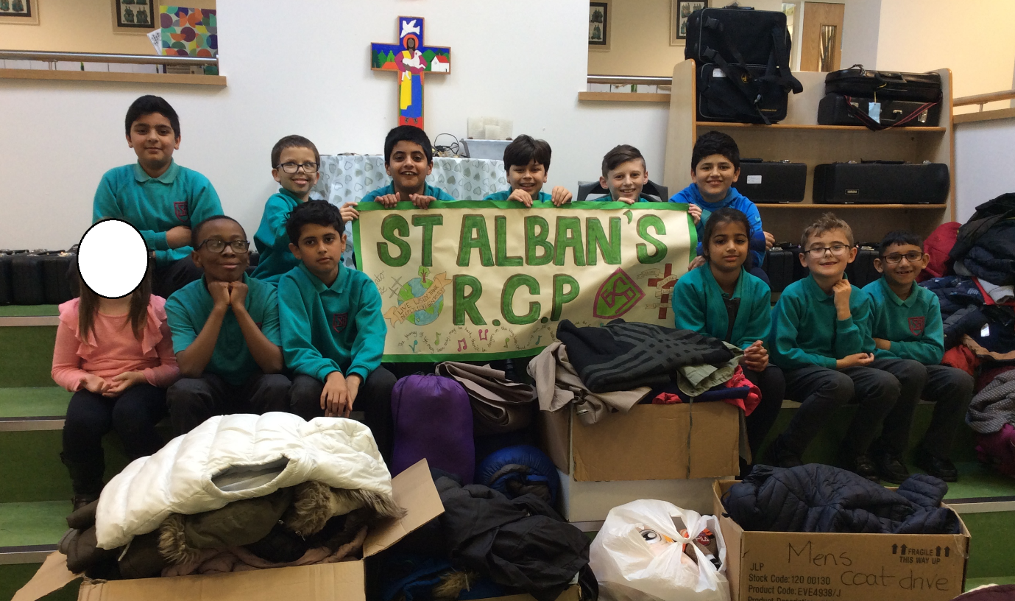

A Team Coat Drive in Aid of Accrington Rotary 2019
93 Coats
43 Jumpers
3 Sleeping bags
Countless hats, gloves, scarves

