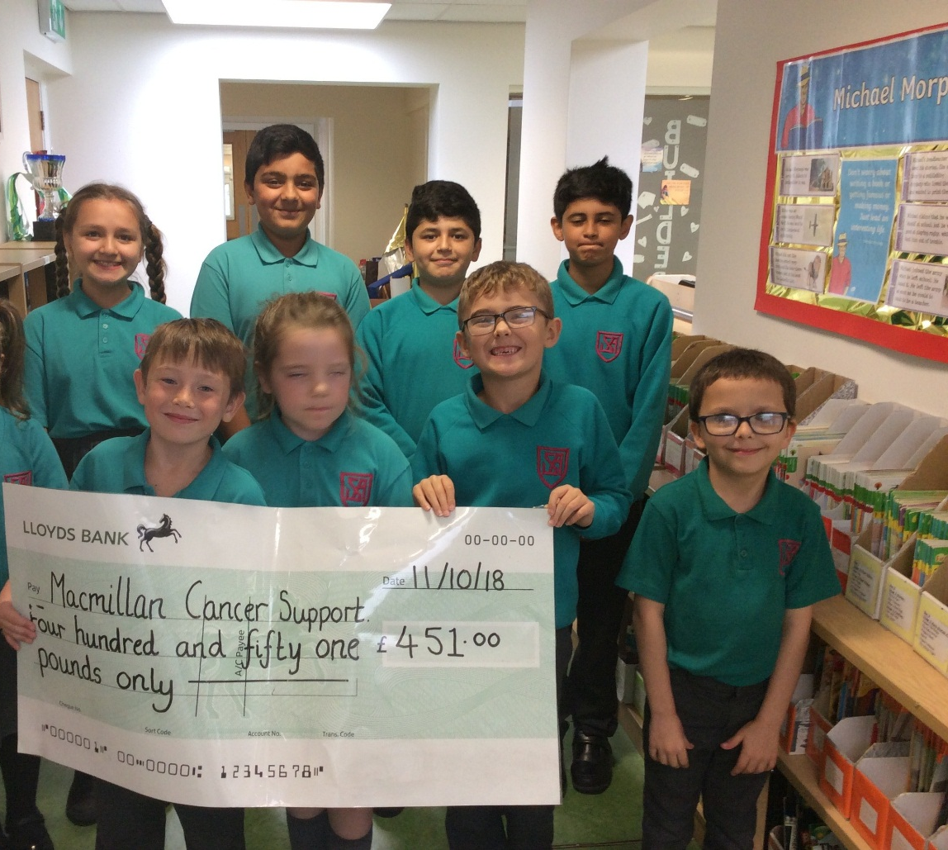

A Team Macmillan Coffee afternoon & staff bake off
Total raised- £451

